API Documentation Strategy and Guideline (Swagger/OpenAPI Specifications)


This document and any attachments submitted with it are confidential and intended solely for the use of project or entity to which it is addressed. If you are not the intended recipient, you are hereby notified that any use, dissemination, forwarding, printing, copying or other use of this document, any attached documents, and the information these documents contain, is strictly prohibited. If you have received this by mistake, please advise the sender immediately and destroy/invalidate the document.
ImPORTANT NOTICE
Submitted to
YASH Technologies Consulting Inc.
Americas | Europe| MENA | Asia | ANZ
09-01-2025
Submitted by

Revision History

Version | Date | Author | Reviewer | Description of the Change
1.0 | 22/01/2025 | Yash Technologies Inc. |  | First version

Table of Contents
Introduction 4
What is OpenAPI 4
OpenAPI vs. Swagger 5
OpenAPI specification (openapi.json) 5
What is Swashbuckle? 5
Enable OpenAPI documentation in an ASP.NET Core Web API 6
Add the Swagger library to the solution: 6
Allow API document file generation 8
Decorating the API code for proper annotations and values: 8
Generating OpenAPI documentation file: 15
Referecnes: 17

Introduction
An API can have great value, but it can't gain traction unless developers know how to use it. Developers want to integrate an API as quickly as they can. Good API documentation helps a developer understand the API's capabilities and how it should be used, making integration more efficient.
Traditionally, all documentation that described an API and how to use it was written by hand. Now we have a standard specification for API descriptions called OpenAPI. Swagger UI provides implementation and testing tooling of the OpenAPI specification for your APIs. Swashbuckle is an open-source package that provides automatic generation of OpenAPI description documents directly from Web API controllers using .NET reflection. Swashbuckle helps you automate the description process, making it easier for teams to generate, maintain, and use OpenAPI-based API documentation. You describe your API and let tools generate rich documentation
Swagger (OpenAPI) is a language-agnostic specification for describing REST APIs. It allows both computers and humans to understand the capabilities of a REST API without direct access to the source code. Its main goals are to:
- Minimize the amount of work needed to connect decoupled services.
- Reduce the amount of time needed to accurately document a service.

What is OpenAPI
OpenAPI is a specification used for describing REST APIs. It's language agnostic, and enables you to describe your entire API including:
- Available endpoints
- Operation parameters
- Authentication methods
- Contact and other information
You can write API specifications in YAML or JSON. With the OpenAPI specification, humans and computers can understand the capabilities of your API without having access to its source code.
The two main OpenAPI implementations for .NET are Swashbuckle and NSwag
For the purpose of API documentation we are leveraging Swasgbuckle.

OpenAPI vs. Swagger
The Swagger project was donated to the OpenAPI Initiative in 2015 and has since been referred to as OpenAPI. Both names are used interchangeably. However, "OpenAPI" refers to the specification. "Swagger" refers to the family of open-source and commercial products from SmartBear that work with the OpenAPI Specification.
Swagger is a set of open-source tools built around the OpenAPI specification. These tools can help you design, build, and document REST APIs. Swagger uses the OpenAPI specification of your API to understand its structure.
For example, Swagger UI is a tool that can visually render documentation in a browser for an API defined with the OpenAPI specification. Swagger Codegen can take the same OpenAPI specification of an API and generate client SDKs.

In short:
- OpenAPI is a specification.
- Swagger is tooling that uses the OpenAPI specification. For example, OpenAPIGenerator and SwaggerUI

OpenAPI specification (openapi.json)
The OpenAPI specification is a document that describes the capabilities of your API. The document is based on the XML and attribute annotations within the controllers and models. It's the core part of the OpenAPI flow and is used to drive tooling such as SwaggerUI.

What is Swashbuckle?
Swashbuckle is an open-source Swagger implementation used for generating Swagger documentation for .NET Core APIs using .NET reflection.
There are three main components to Swashbuckle:
- Swashbuckle.AspNetCore.Swagger: This component is the Swagger object model and middleware to expose SwaggerDocument objects as JSON endpoints.
- Swashbuckle.AspNetCore.SwaggerGen: This library is a Swagger generator that builds SwaggerDocument objects directly from your routes, controllers, and models. The library is typically combined with the Swagger endpoint middleware to automatically expose Swagger JSON.
- Swashbuckle.AspNetCore.SwaggerUI: This package is an embedded version of the Swagger UI tool. It interprets Swagger JSON to build a rich, customizable experience for describing the web API functionality. It includes built-in test harnesses for the public methods.
Because these libraries are added to your app, they generate and visualize your API documentation from the latest version of your API. They create living documentation, always in sync with the latest code.

Enable OpenAPI documentation in an ASP.NET Core Web API

Add the Swagger library to the solution:
- Add Swashbuckle to your project by running the dotnet add package command.
dotnet add package Swashbuckle.AspNetCore
- Open the Program.cs file.
- At the top of the file, add another using entry:
using Microsoft.OpenApi.Models;
using System.Reflection;

The Microsoft.OpenApi.Models namespace includes classes that represent various components of the OpenAPI Specification. These components are used to describe the structure, behavior, and security of your API in a machine-readable format
The using System.Reflection is required to generate the XML file which is used by swashbuclke for API documentation
- Add and configure Swagger middleware
Add the Swagger generator to the services collection in Program.cs
Note: the below code is sample for Track and Trace API. Developers are requested to changes the value(s) appropriatly. The comments followed by code lines are added for the code explanation purpose only and should bot be part of actual code.

builder.Services.AddSwaggerGen(options =>
{
options.SwaggerDoc("v1", new OpenApiInfo
{
Version = "1",
Title = "Shipment Tracking",
Description = "APIs for Tracking Shipments"
});
//Comment: The above code lines, adds the Swagger generator to the services collection. SwaggerUI shows the REST APIs in your project in a user-friendly UI, so that you can test them in the browser. For this UI to render, you need the JSON file that expresses the details of the APIs[name, input arguments, types, etc], that JSON is being generated by this Swagger Generator

// Comment: v1 : Specifies the version identifier of the Swagger document. OpenApiInfo Contains metadata for the Swagger/OpenAPI documentation like Version = "1" Sets the version of the API being documented. Title = " Shipment Tracking " - The title displayed in the Swagger UI or documentation. Description = "APIs for Tracking Shipments" A short description of the API.

var xmlFilename = $"{Assembly.GetExecutingAssembly().GetName().Name}.xml";
options.IncludeXmlComments(Path.Combine(AppContext.BaseDirectory, xmlFilename));

//comment: This above code snippet is used to include XML comments from your codebase into the Swagger/OpenAPI documentation generated by Swashbuckle in an ASP.NET Core application. This code line ensure that the swagger generator reads the XML comments which has been added for each API endpoint description and make them available in API documentation. Developer need to add using System.Reflection namespace in Program.cs file to .

options.AddSecurityDefinition(Constants.ApiKey, new OpenApiSecurityScheme
{
Description = $"{Constants.ApiKey} must appear in header",
Type = SecuritySchemeType.ApiKey,
Name = Constants.ApiKey,
In = ParameterLocation.Header,
Scheme = "ApiKeyScheme"
});
var key = new OpenApiSecurityScheme()
{
Reference = new OpenApiReference
{
Type = ReferenceType.SecurityScheme,
Id = Constants.ApiKey
},
In = ParameterLocation.Header
};
var requirement = new OpenApiSecurityRequirement
{
{ key, new List<string>() }
};
options.AddSecurityRequirement(requirement);
});

//Comment: the above code snippet is a configuration for Swashbuckle to include an API Key-based authentication mechanism in the generated Swagger UI. This ensures Swagger UI now enforces the use of the API key for all endpoints defined in the documentation. An Authirize button start apprearing in Swagger UI with the above code which requires the API key to be passed to call the API endpoints.
if (app.Environment.IsDevelopment())
{
app.UseSwagger(); // Defaults to OpenAPI 3.0 format
app.UseSwaggerUI();
}

//comment: the above code adds the middleware that serves the Swagger/OpenAPI specification as a JSON document. By default, this document is available at the "/swagger/v1/swagger.json end point. If no version is mentioned with app.UseSwagger(); then the default OpenAPI 3.0 document is generated which is the latest version.

Allow API document file generation
To ensure that generator generates the file and decorate the API documentation with the XML attributes you need to add GenerateDocumentationFile>True</GenerateDocumentationFile> in proj.cs file.

Decorating the API code for proper annotations and values:
In the above section the middleware configuration is mentioned which influence how the API document is generated. The below sections provide more details on how to decorate the code to generate a proper API document.
- The Very first thing is to specify the metadata of the entire API project which summarizes the overall purpose of the multiple end points/routes within the project. Developer should use the below code to specify this.

builder.Services.AddSwaggerGen(options =>
{
options.SwaggerDoc("v1", new OpenApiInfo
{
Version = "1",
Title = "Shipment Tracking",
Description = "Allows users to track shipments in real-time, provide load statuses, update shipment tracking status."
});

The v1 in the above code specify the path where the swagger generates the swagger.json file dynamically. The value appears in the swagger UI when a developer locally run the API project. By default the path generate us swagger/v1/swagger.json.
Develoeprs are expected to keep the v1 as is and provide the following value based on the API project they are working on. The vlaues below are for illistration and guidelines purpose only, please provide your own values.
Version = "1"

provide the version of API to let the API consure know what API version document he is referring.

Title = "Shipment Tracking"

provide the proper title of API which conveys what the purpose of these APIs. For example Shipment Tracking suites better than Track & Trace title. Please note that the title provided here appears in the APIM hence follow same naming standard for title.

Best Practices for Title
The Title represents the name of the API and should clearly identify the API's purpose. Consider the following best practices:

a. Be Clear and Concise
- Use a title that succinctly describes the API's primary function or domain.
- Avoid overly generic titles like "My API" or "Backend Services."

Best Practices for Description
The Description provides additional details about the API, helping consumers understand its purpose and capabilities.

a. Define the API's Purpose
- Explain what the API does in simple terms.
- Include key use cases or the main problems it solves.

b. Include Features
- Highlight important features or functionality provided by the API.
- Example: " Allows users to track shipments in real-time, provide load statuses, update shipment tracking status."
Once you specify the above detail these appreas in Swagger UI as below

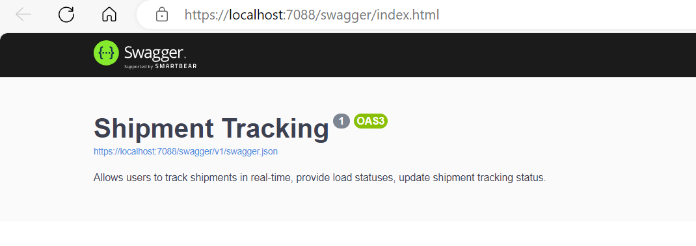
- Enable the Autorize button to ensure that developer pass the API Key by which the Backend API is secured. Add the below code and this will make sure the Autorize button to appear for API Key.

options.AddSecurityDefinition(Constants.ApiKey, new OpenApiSecurityScheme
{
Description = $"{Constants.ApiKey} must appear in header",
Type = SecuritySchemeType.ApiKey,
Name = Constants.ApiKey,
In = ParameterLocation.Header,
Scheme = "ApiKeyScheme"
});
var key = new OpenApiSecurityScheme()
{
Reference = new OpenApiReference
{
Type = ReferenceType.SecurityScheme,
Id = Constants.ApiKey
},
In = ParameterLocation.Header
};
var requirement = new OpenApiSecurityRequirement
{
{ key, new List<string>() }
};
options.AddSecurityRequirement(requirement);
});

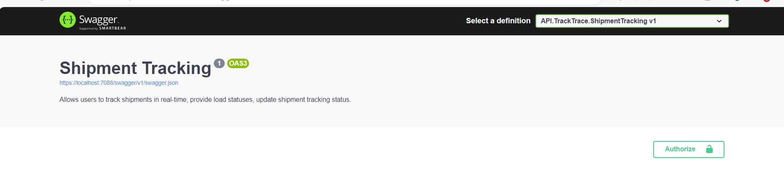
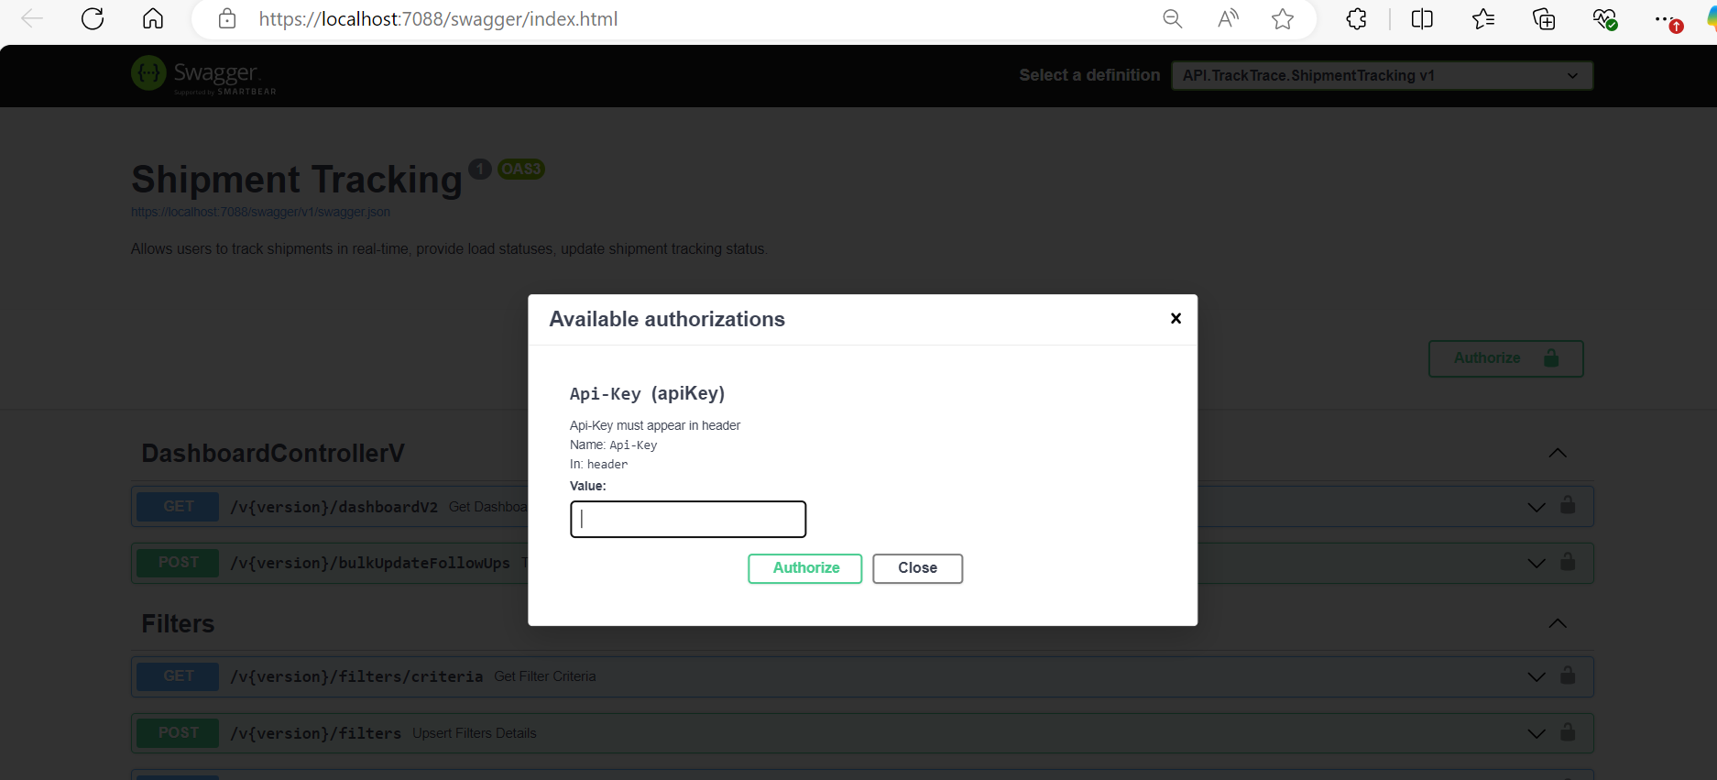

- Decorating the API Endpoints with XML comments: In order to provide more details about the API, the API endpoints should be enriched with XML comments and annotations. Ensure that following information is always added at minimum to API documentations.
  - HTTP Verb Attribute to indicate the method type. e.g [HttpGet] or [httpPost]
  - Route Attribute to define the endpoint route url e.g. [Route("loads/tracking")]
  - XML comments: the XML comments provided at the top of method would decorate the API document and hence should be used to provide meaning full information to API consumers. Include the below minimum XML comments with each Method/endpoint
    - summary: provide meaningful summary of the Method
    - param: Mention all the param which this method requires and explain the paramater. Ensure to decorate the function parameter with [Required] attribute if they are required
    - returns: Provide the details what this method is expected to retun in case of success.
    - Possible Responses:Add all the possible response which this method can retrun to consumers. e.g 200, 400, 401,404 and 500. Ensure that your code handle there response as stated.
Following code provide a sample for decorating the API endpoint and the resultant swagger UI which is generated on developers local machine. Please note the code below is for illustration and guidelines purpose only.
/// <summary>
/// Retrieves detailed information about a specific load.
/// </summary>
/// <param name="loadNum"> The unique identifier of the load for which details are requested. This is a required parameter.</param>
/// <param name="userEmail">The email address of the user who is requestng the load detials.</param>
/// <returns>Returns an object containing detailed information about the load.</returns>
/// <remarks>
/// This endpoint retrieves the details of a specific load associated with the provided load number and user email.
///
/// Possible Responses:
/// - 200 OK: Successfully retrieved the load details.
/// - 400 Bad Request: Missing or invalid parameters.
/// - 404 Not Found: Load not found for the specified load number and user email.
/// - 401 Unauthorized: User not authorized to access this load.
/// - 500 Internal Server Error.
/// </remarks>

[HttpGet]
[Route("loaddetails")]
public async Task<ActionResult<LoadDetailsResponse>> GetLoadDetails([Required]string loadNum, [FromHeader][Required]string userEmail)
{
_logger.Log(LogLevel.Information, "GetLoadDetails Get LoadDetails() called. load number :{LoadNum}, userEmail {UserEmail}", loadNum, userEmail);
LoadDetailsResponse response = await _loadsManager.GetLoadDetails(loadNum, userEmail);
if (string.IsNullOrEmpty(response.ErrorMessage))
{
_logger.LogInformation("LoadsController GetLoadDetails(), Success response object: {Response}", JsonConvert.SerializeObject(response));
return Ok(response);
}
else
{
DefaultResponse defaultResponse = new DefaultResponse
{
Success = false,
Message = response.ErrorMessage
};
if (response.ErrorMessage == Constants.Messages.NoLoadFound)
{
_logger.LogInformation("LoadsController ResolveLoad(), NotFound object: {Response}", JsonConvert.SerializeObject(defaultResponse));
return NotFound(defaultResponse);
}
else
{
_logger.LogInformation("LoadsController ResolveLoad(), NotFound object: {Response}", JsonConvert.SerializeObject(defaultResponse));
return BadRequest(defaultResponse);
}
}

}
Screen shots of Swagger UI generated with above sample code.
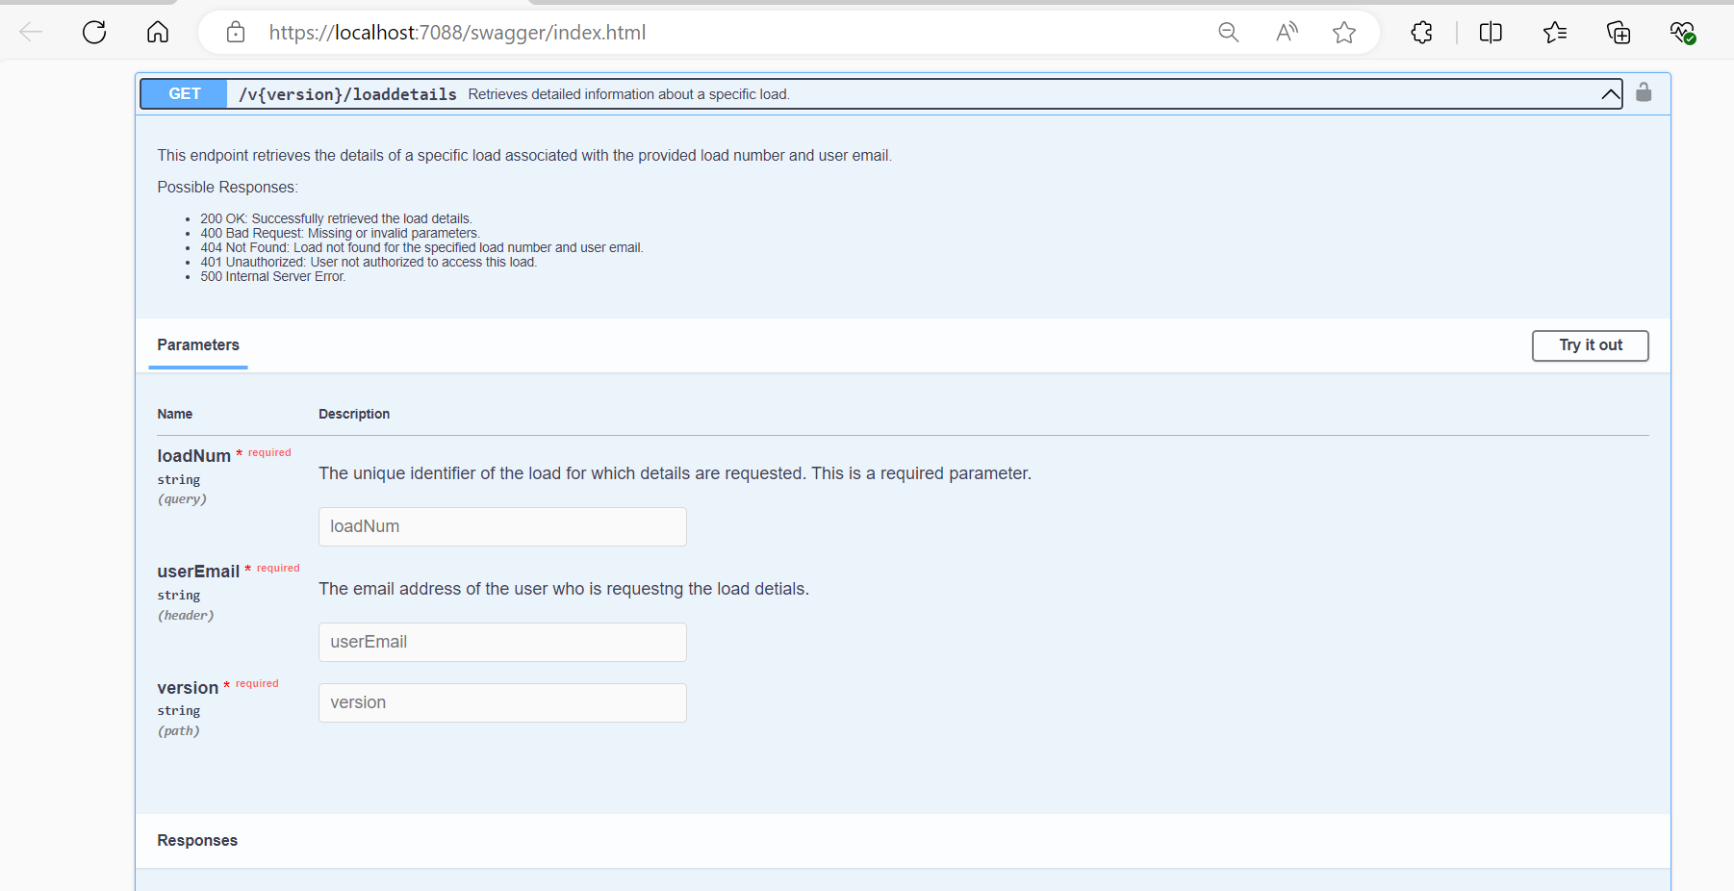
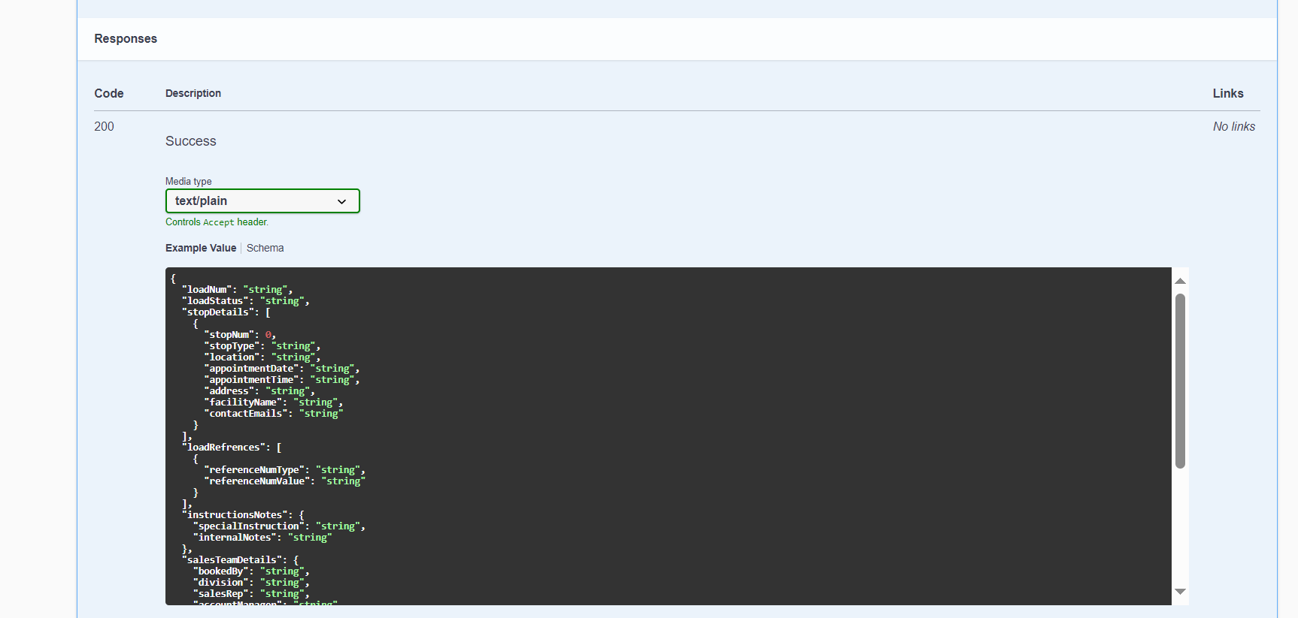

Sample 200 OK response

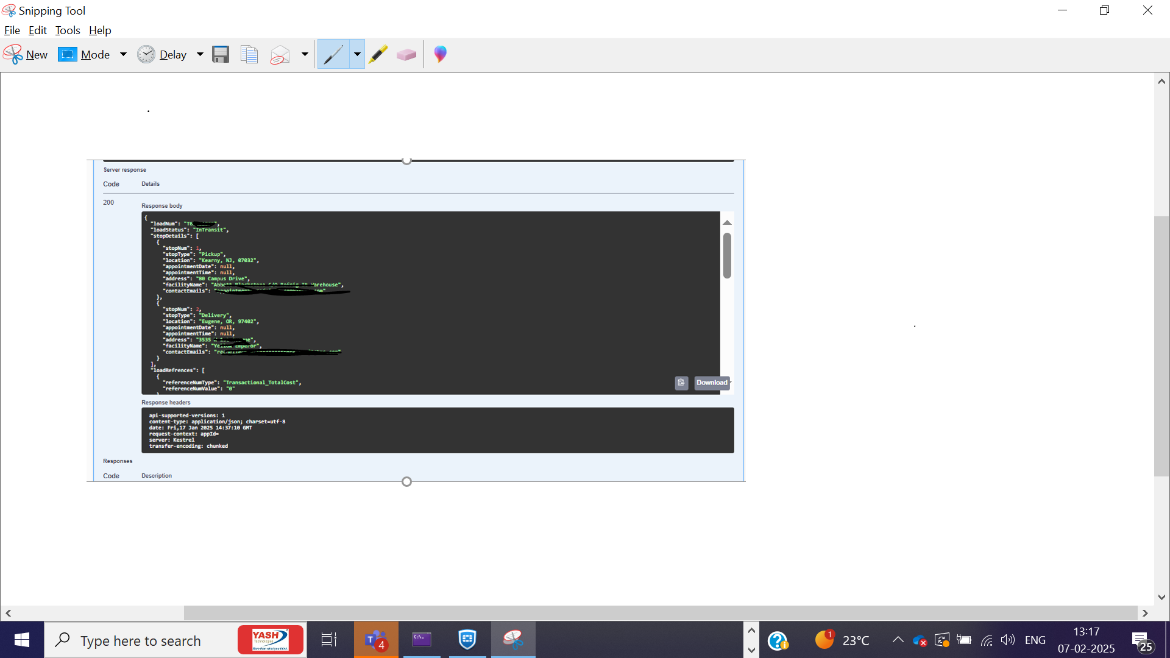
Sample 404 response
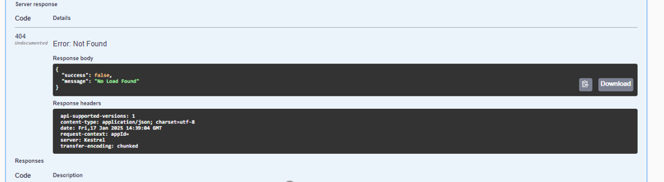
Sample 400 response
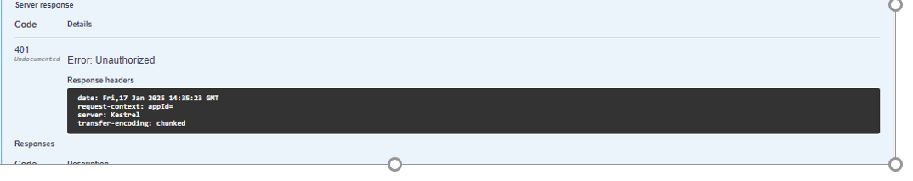

Generating OpenAPI documentation file:
Once you decorate the API and its all endpoints you can generate swagger.json file. The swagger.json file generated by Swashbuckle is a machine-readable representation of the OpenAPI Specification (OAS) for an API. It describes the endpoints, operations, input parameters, response types, and other details about the API in JSON format.
This file is typically served at a URL like /swagger/v1/swagger.json in a Swashbuckle-enabled application. Developer has to download this file and checkin in Repo to use this file for onboarding the API in APIM.
Developer to run the applicaiton locally and then click on the link https://localhost:7088/swagger/v1/swagger.json which open the swagger.json file.
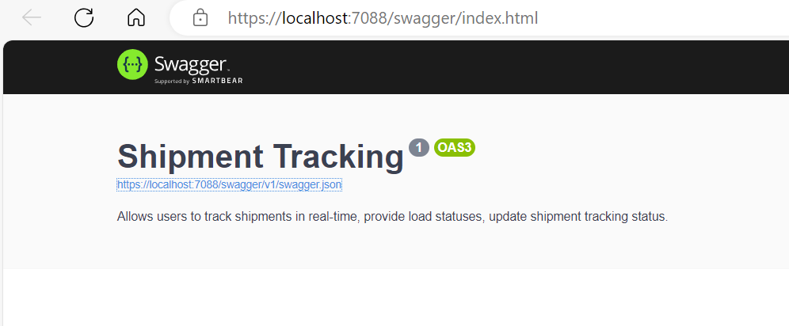
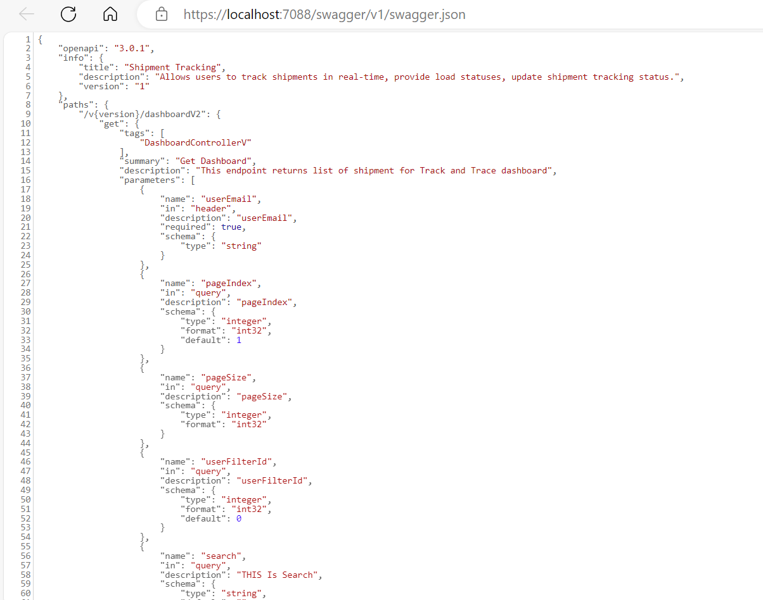

Save this file with a Uniue API Name e.g. ShipmentTracking.JSON. This OpeAPI file would be used to import/onbaord the APIs into APIM instance.

Referecnes:
Follwing sites, documents has been refereced to comeup with this API documentation guidelines.
https://developers.dialpad.com/reference/download-api-collection
https://learn.microsoft.com/en-us/aspnet/core/tutorials/getting-started-with-swashbuckle?view=aspnetcore-8.0&tabs=visual-studio
https://learn.microsoft.com/en-us/training/modules/improve-api-developer-experience-with-swagger/
API Documentation & Design Tools for Teams | Swagger
API Documentation | LogisticsOS

